​The Heart Is On The Outside​
Feast of the Sacred Heart, 2016
Reflections from an RSCJ

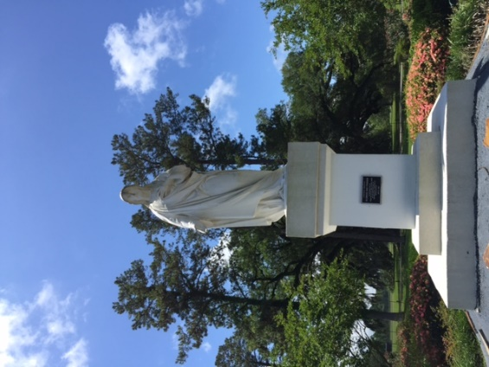
Grand Coteau, Louisiana

In pondering our Feast, my prayer begins with the traditional statue of the Sacred Heart that faces every person who enters Sacred Heart School of Halifax. I am guessing that most of our schools around the world have this same statue.
When I was a student at Duchesne Academy of the Sacred Heart in Omaha, Nebraska I was invited to consider - deeply - the significance of this artistic image of the Sacred Heart. One day, Sr. Christine paused from her cleaning, tapped me on the arm (she was too short to reach my shoulder) and in broken English she said: "Zee Heart is on zee OUTSIDE." She repeated this simple phrase a couple of times and then continued to clean. I don't know if I ever heard her voice before that, nor after that day. With tears in my eyes I stood speechless - no reply was needed - I understood from her that the Heart of Jesus is not hidden inside where it cannot be seen, rather it is on the outside for all to see, for all to experience, a heart visible to all as a place of shelter, love, kindness, acceptance, growth, challenge and hope. That was 40 years ago.
In 1995, I was living in Grand Coteau, Louisiana. It was my 6th year after 'first vows' and time to write my 'discernment of call' which is also a request to enter the final stage of initial formation, and permission to prepare for final vows in the Society of the Sacred Heart. I was almost finished with the document when I knew I couldn't proofread it one more time without taking a walk. The campus was quiet, and shadows were long at that early evening hour. I found myself sitting down on the front step and looking at the large statue of the Sacred Heart that is between the building and Oak Alley. Aloud I said to Jesus - why am I doing this with my life? The response: It is the desire of my love. To this day, I am convinced that the answer did not come from me or Jesus - it came from both of us at the same time. That kind of oneness is a profound gift. I sat there for a few minutes trying to grasp what had just occurred, and then with courage and confidence walked back to my room and finished the discernment of call.
In Halifax, we have three of these statues of the Sacred Heart, and I'm grateful we have been able to repair some damaged fingers on one, and give each a fresh coat of paint. We are considering changes to our campus to improve the program space for students, and in conversations the question repeatedly arises: "What about Jesus?" Jesus, with his Sacred Heart on the outside will never be far from sight. He will always be with us, giving us courage and confidence to carry forward our mission of discovering God's love and making it known!
As I was preparing this reflection, one of our RSCJ Sister's died. Her death is a mix of sadness for those who will miss her, relief that she's not suffering anymore, and joy that she is with God in a way we can only imagine. Her death reminds the rest of us that our own lives are finite, that most of the "securities" we shelter behind are no security in the end, and that real joy is found when we live with 'zee heart on zee outside' ... trusting the desire of our Love.

Anne Wachter, RSCJ
Halifax, Nova Scotia - Canada
Feast of the Sacred Heart, 2016

